Network lab cycle 4

1)

#!/bin/sh

#21mca005

#sample script

echo "what is your name?"

read person

echo "HELLO, $person"

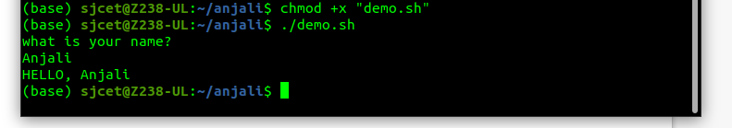

**2)Shell Program to check whether the number is odd or even in the list**

echo "Enter number"

read num

q=`expr $num % 2`

if [ $q -eq 0 ]

then

echo " $num is an EVEN number !!"

fi

echo "$num is an ODD number !!"

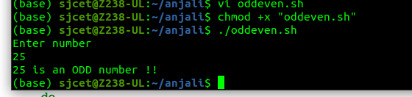

**3)shell script for factorial of a number**

echo “Enter a number”

read num

fact=1

while [ $num -gt 1 ]

do

fact=$((fact * num)) #fact = fact * num

num=$((num - 1)) #num = num - 1

done

echo $fact

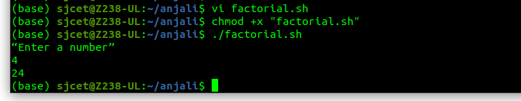

**4)Sum of all digits - Shell Script**

echo "Enter a number"

read num

sum=0

while [ $num -gt 0 ]

do

mod=$((num % 10))

sum=$((sum + mod))

num=$((num / 10))

done

echo $sum

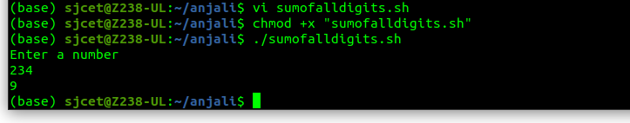

**5)Print numbers 1 to 100 using while loop - Shell Script**

i=1

while [ $i -le 100 ]

do

echo $i

i=`expr $i + 1`

done

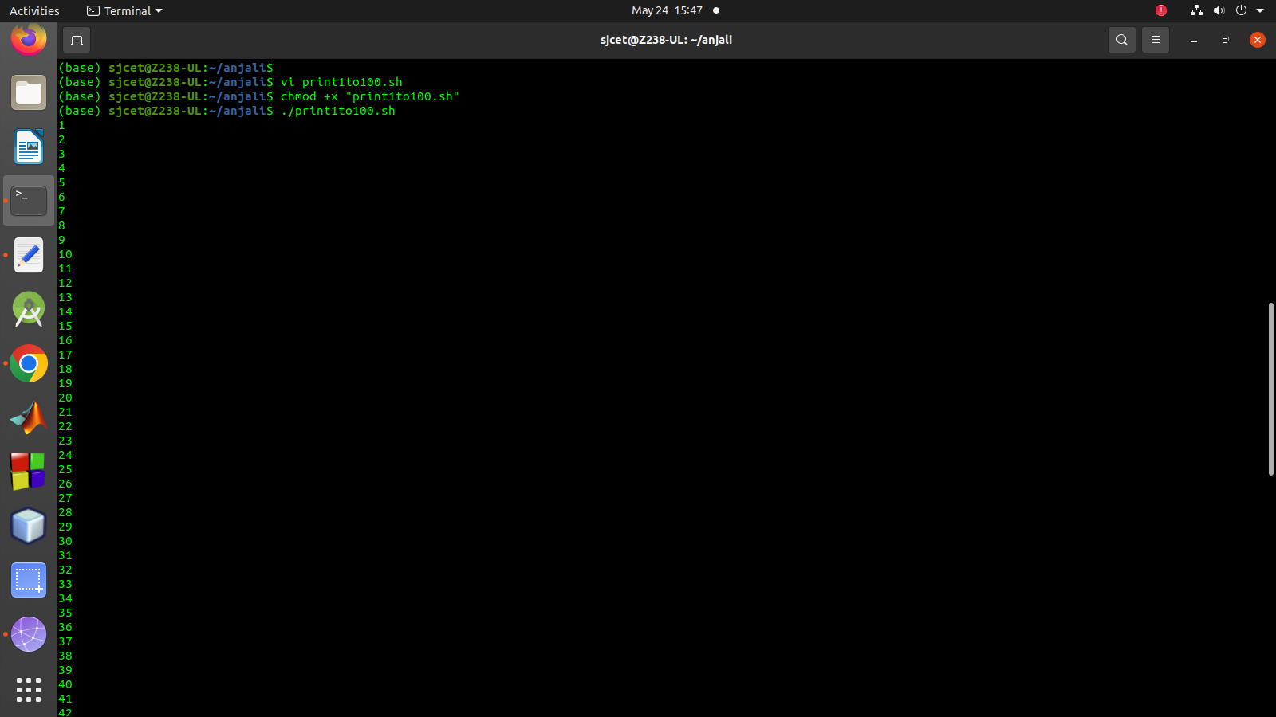

**6) Largest of n numbers - Shell Script**

#shell script for largest of n numbers

echo “Enter Size(N)”

read N

i=1

max=0

echo “Enter Numbers”

while [ $i -le $N ]

do

read num

if [ $i -eq 1 ] then

max=$num

else

if [ $num -gt $max ]

then

max=$num

fi

fi

i=$((i + 1))

done

echo “$max is the largest number”

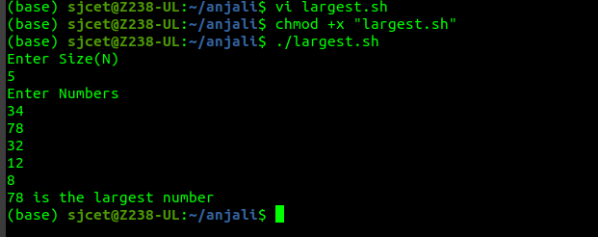

**7) Average of n numbers - Shell Script**

#shell script to find average of n numbers

echo “Enter Size(N)”

read N

i=1

sum=0

echo “Enter Numbers”

while [ $i -le $N ]

do

read num

sum=$((sum + num))

i=$((i + 1))

done

avg=$(echo $sum / $N | bc -l)

echo “$avg is the average”

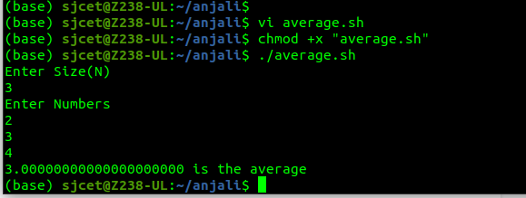

**8)Sum of n numbers using while loop - Shell Script**

#shell script to find sum of n numbers

echo “Enter Size(N)”

read N

i=1

sum=0

echo “Enter Numbers”

while [ $i -le $N ]

do

read num

sum=$((sum + num))

i=$((i + 1))

done

echo $sum

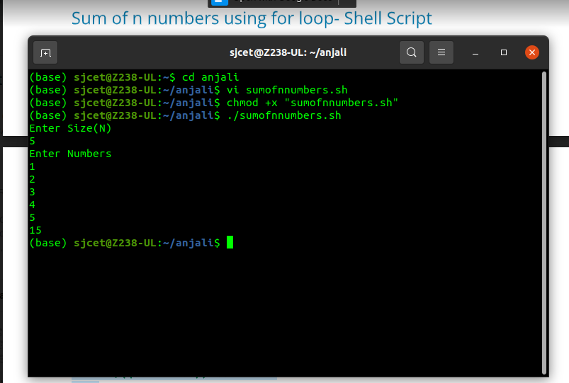

**9)Shell script for finding greatest of three numbers**

#shell script to find the greatest of three numbers

echo “Enter Num1”

read num1

echo “Enter Num2”

read num2

echo “Enter Num3”

read num3

if [ $num1 -gt $num2 ] && [ $num1 -gt $num3 ]

then

echo “$num1 is the greatest of three numbers”

elif [ $num2 -gt $num1 ] && [ $num2 -gt $num3 ]

then

echo “$num2 is the greatest of three numbers”

else

echo “$num3 is the greatest among the three”

fi

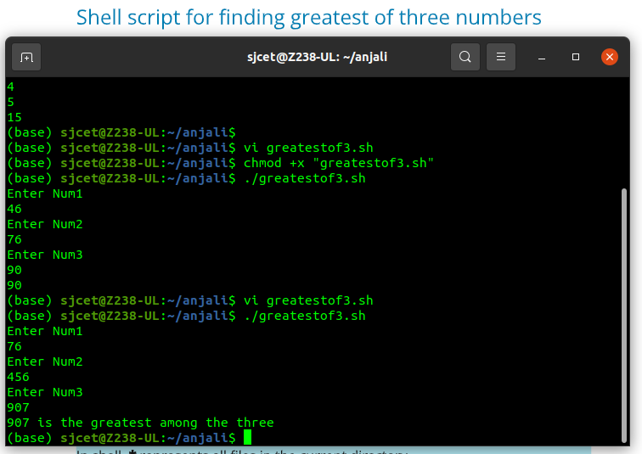

**10)Multiplication of two numbers using expr in shell script**

#shell program to multiply two numbers using expr

echo "Enter a number"

read num1

echo "Enter second number"

read num2

ans=`expr $num1 \* $num2`

echo "The sum of both $num1 and $num2 is : $ans"

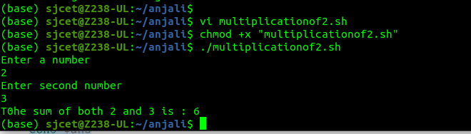

11)**Shell script to compare two strings**

#shell script to compare two strings

read -p “Enter two strings: “ str1 str2

if [ $str1 == $str2 ]

then

echo “Equal”

else

echo “Un Equal”

fi

